VIII TUENIEJ WIEDZY O KRAJACH ANGLOJĘZYCZNYCH
PAŹDZIERNIK 2017 ROK KOD:
LICZBA PUNKTÓW:
HISTORY
- Complete the text with words:

Norman Conquest , the North Sea , the Latin language , 400, The Romans, two and a half million, four, 410 AD, the 8th Century AD, 1485.

The first men and women came to Britain over ¹……………………………..years ago. They were hunters and gatherers of food who used simple stone tools and weapons. Much of Britain was covered in forests`
² …………………….. came to Britain 2000 years ago. They changed our country and made its mark on Britain, and even today, the ruins of Roman buildings, forts, roads, and baths can be found all over Britain.
Britain (not Scotland) was part of the Roman Empire for almost ³……….. years! The Romans divided England into ⁴ ………..….. areas centred by the following towns London, Cirencester, York and Lincoln.
By the time the Roman armies left around ⁵…………….., they had established medical practice, a language of administration and law and had created great public buildings and roads.
Many English words are derived from ⁶……………………. of the Romans.
When they had gone there was no strong army to defend Britain, and tribes called the Angle, Saxon, and Jute (the Anglo-Saxons) invaded. They left their homelands in northern Germany, Denmark and northern Holland and rowed across ⁷………………….. in wooden boats.
The Viking Age in Britain began about 1,200 years ago in ⁸ ……………….. and lasted for 300 years.
The Middle Ages in Britain cover a huge period. They take us from the shock of ⁹…………………………., which began in 1066, to the Black Death of 1348, the Hundred Years' War with France and the War of the Roses, which finally ended in ¹⁰ ……………. .
…/10

- Write the given dates next to the events:

1620, 1536, 1953, 1707, 1666, 1801, 1901, 1558 , 1973, 1945

LP. | EVENT | DATE
1 | Act of Union joins Wales and England
2 | Elizabeth I accedes to the throne
3 | The Pilgrim Fathers set sail for New England from Plymouth, aboard the ‘Mayflower’ to escape religious persecution in England
4 | Great Fire of London
5 | England and Scotland officially became one country – Great Britain
6 | The United Kingdom is created when Great Britain (England, Scotland and Wales) and Ireland are formally joined under the Act of Union
7 | Queen Victoria dies
8 | The end of World War Two
9 | Coronation of Queen Elizabeth II
10 | Britain joins the European Economic Community

…/10

GEOGRAPHY
 | 1. | 2 | 3 | 4
Constituent  countries | ……… | …………. | .  …………… | ……
Capital cities | ………. | ……… | …………… | ……
- Match the places to the numbers on the map.
What are the capital cities of the constituent countries?
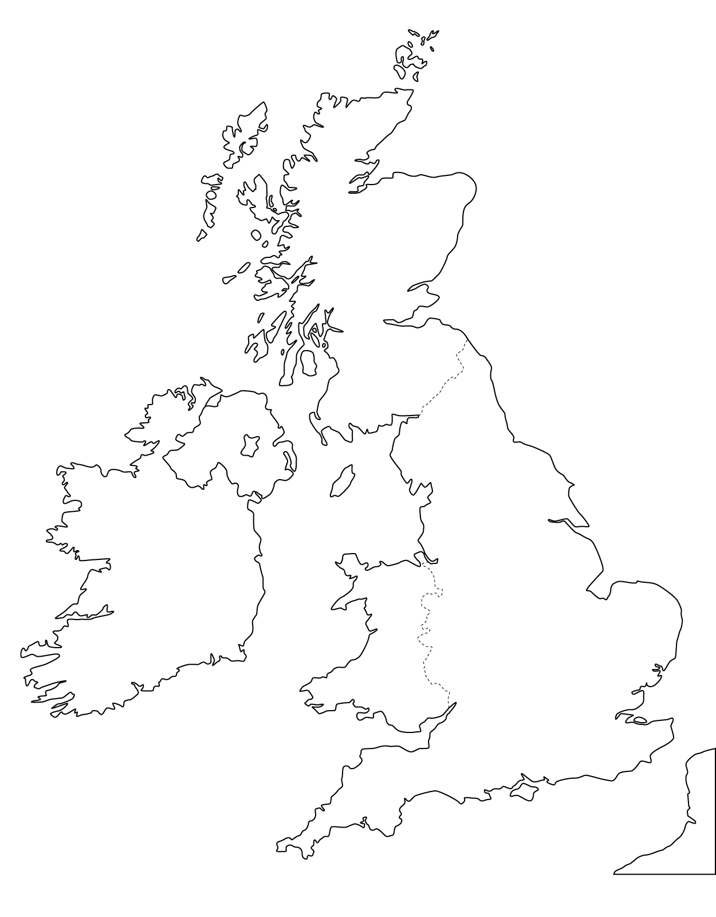…/8
- England
- Scotland
- Wales
- Northern Ireland

4
2
1
3
- Write T (true) or F (false)

1 | Ben Nevis is the highest mountain in Canada
2 | Ulster is another name for Northern Ireland
3 | Cardiff lies on the River Thames
4 | Lake Tekapo is located in New Zealand
5 | Mount Snowdon is in Wales
6 | Belfast is the capital city of the Republic of Ireland
7 | There are 53 US states
8 | Alaska is a part of the USA
9 | British Columbia is a province in Canada
10 | New Zealand is an island nation in the southwestern Pacific Ocean.

…/10
SYMBOLS
- Match the names of the native people with the countries:

- Australia A. Inuits
- New Zealand B. Aborigines
- the USA and Canada C. Maoris
- Canada and the USA D. Indians

Country | 1 | 2 | 3 | 4
Native People
…/4
- Match the animal symbols to the countries.

- The United Kingdom A. kangaroo
- Australia B. beaver
- New Zealand C. kiwi
- The USA D. lion
- Canada E. bald eagle

Country | 1 | 2 | 3 | 4 | 5
Native People
…/5
- Match the anthems’ quotes with the appropriate countries:
- “God save our gracious Queen,
Long live our noble Queen.”

- “Oh say, can you see, by the dawn’s early light,
What so proudly we hailed at the twilight’s last gleaming.”

- “... Our home and native land!
True patriot love in all thy sons command”
- The USA
- New Zealand
- Australia
- Canada
- The UK

- “Our home is girt by sea;
Our land abounds in native’s gifts.”

- “In the bonds of love we meet,
Hear our voices, we entreat,
Good defend our Free Land”
Country | 1 | 2 | 3 | 4 | 5
Anthem
.../5
CULTURE AND LITERATURE
- Put the statements in the correct place.
W. Shakespeare; C.S. Lewis; Scotland; Duncan; Albus; Hogwarts; Hobbit; nick name Robert Galbraith; J.R.R. Tolkien; Middle-Earth; actor; Bilbo Baggins; Ch. Dickens; "father" of modern fantasy literature; The Silver Chair; Narnia; Eustace Scrubb; essayist; A Christmas Carol; Jacob Marley; Macbeth; London; the greatest novelist of the Victorian era; J.K. Rowling, Harry Potter and the Cursed Child
Lp. | Authors | Titles | Characters | Place | Others
1 | W. Shakespeare |  |  |  | actor
2 |  | A Christmas Carol |  |  | the greatest novelist of the Victorian era
3 | J.R.R. Tolkien | Hobbit
4 |  |  |  | Narnia | essayist
5 | J.K. Rowling
…/8
Write the dates next to the festivals (eg. 1st May)

Festival | Date
Christmas
Halloween
New Year’s Day
Valentine’s Day
Bonfire Night
April Fool’s Day
Boxing Day
The Independence Day

Remembrance Day

St George's Day (England's National Day)

…/10
- RECOGNIZING OBJECTS AND PLACES
Look at the pictures. Write down the name of the object or place and the country of its origin.
LP. | Country | Name of the object/place
1
2
3
4
5
6
7
8
9
10

…/10

Read the sentences carefully!
- Then watch the film twice and decide whether
the sentences are TRUE or FALSE
lp | BIG BEN – BEHIND THE SCENES | TRUE or FALSE
1. | Big Ben is the most famous clock.
2. | Big Ben is the name of the bell inside the tower.
3. | The bell can be visited only by the British citizens with a special permission.
4. | There are 330 steps in the clock tower
5. | The clock has been ticking almost uninterruptedly for 300 years.
6. | The clock is called the king of clocks.
7. | Keeping the clock on the correct time involves golden rings.
8. | The penny must be removed to slow down the clock.
9. | The bell tolls only once a day
10. | The bell is 9 feet wide.

…/10

