- Harry the Dog
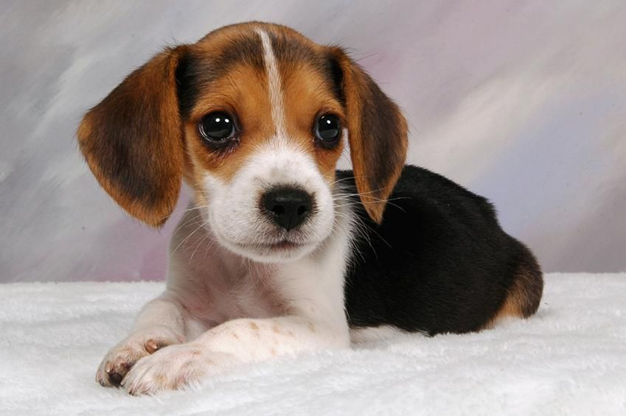
Look! That’s me, Harry. I am a beagle. I live with a very nice family in a little house in Blueberry Valley. I’m brown, black and white. I’ve got a big black nose, long soft ears, and brown eyes. The white tip of my tail is always up.
I get up early in the morning and go for a walk in the park. I meet my friends there. I love playing with other dogs. We run, chase and play together with a ball. I like to be with people very much. Kids love to stroke and cuddle me. I always try to lick their faces.
The family teaches me tricks. I learn very fast. I can sit, give you a paw, catch and roll over. I’m never tired so I can do it for hours. I am always happy to go for a walk or jog with my family. But I like it best when they ask me to find something. I’m very good at searching.
I hate when they wash me. I don’t like to be wet. But the worst thing is to be alone. When my family goes out I feel so sad. But they always come back and bring me treats! I love my family!
RZECZOWNIKI | CZASOWNIKI | PRZYMIOTNIKI
face – twarz  paw – łapa  tail– ogon  tip – koniuszek  treat – gratka (tu: przysmak dla psa) | bring – przynieść  chase – gonić  cuddle – przytulać  lick – lizać  roll over – turlać się  search – szukać  stroke – głaskać  try - próbować | alone – sam  best – najlepszy  fast – szybki  sad – smutny  wet – mokry  worst- najgorszy

(Harry, the Dog’s Adventures. Poziom A1. Czytanki i ćwiczenia w języku angielskim dla dzieci. Red. A. Bator. Wyd. Aksjomat, 3-5).

