IV TURNIEJ WIEDZY O KRAJACH ANGLOJĘZYCZNYCH
TEST
SZKOŁA:……………. LICZBA PUNKTÓW………/60

Symbols

- You are going to listen to the anthems of Canada, the USA, United Kingdom and Australia. Number the order of their presentation:
… Canada
… The USA
1 Australia
… United Kingdom …/3

- Match the names of the countries and of the flags to the apropriate picture.

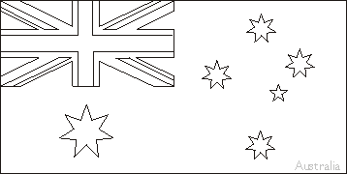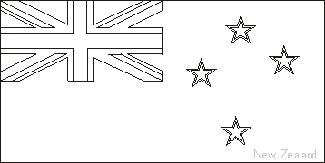

…………………………………………………………………………………………………
…/2
Complete the sentences:
The flag of the USA is called ……………………….……………………………………. .
The flag of UK is called ……….............………………………………………………… . ..../2
Geography

- Give the names of the capital cities:
The USA ………………….....
Great Britain ………………. …….
Canada …………………….
Australia …………………….
New Zealand ……………………. …/5

- Write the names of four constituent countries of Great Britain
…………… ……., …………………….., …………………, ………………… …./4

- Complete the sentences with the names of the countries:
- Mount Kosciuszko is a mountain located in the Snowy Mountains in………..
- On the flag of ……………. there is a red maple leave.
- Boston is a city in …………….
- The hottest lake called Frying Pan is located in ……………………
…./4

- New York lies on the banks of the river:
- Mississippi
- Hudson
- Thames
- Avon …/1

- The Rocky Mountains are in
- Northern America
- Australia
- United Kingdom of Great Britain and Northern Ireland
- New Zealand …/1

- Match the names of the native people with the countries:
Inuits Australia
Aborigines New Zealand
Maoris the USA and Canada
Indians Canada …/3

- The official languages in Canada are ………………………. and ……………….. …/2

- What animal is a symbol of New Zealand?
- a kangaroo
- a beaver
- a kiwi
- a bear …/1

Literature

- Decide whether the sentences are true (T) or false (F)
William Shakespeare was born in London …..
Shakespeare was a playwright and he also acted on the stage. …..
Shakespeare wrote Romeo and Juliet, Hamlet, Sonnets, As You Like It. …..
“To be or not to be it is a question” comes from Shakespeare’s “Macbeth” …. …/4

- Match the authors’ names with the books’ titles
Clive Staples Lewis Harry Potter and the Philosopher's Stone
J.R.R. Tolkien The Silver Chair
J.K. Rowling The Fellowship of the Ring
W. Shakespeare A Christmas Carol
Ch. Dickens Macbeth
…/4

- Complete the titles with the missing word:
- Harry Potter and the Chamber of ……………………….
- The ……………, the Witch and the Wardrobe
- The ………… of the King
- ….. Lear …/4

- Put the names of the characters from the table in the correct place.

Remus Lupin, Marley's ghost, Lucy Pevensie, Gandalf, Prince Caspian, Ebenezer Scrooge, Thorin, Hermione Granger, White Witch, the Ghost of Christmas Past, Dolores Umbridge, Bilbo Baggins, Harry Potter

Harry Potter | The Chronicles of Narnia | The Hobbit | Christmas Carol
Harry Potter
…/6
Festivals

- Match the dates with the appropriate festival
Christmas 5th November
Halloween 17th March
New Year Day 1st April
Valentine’s Day 25th December
St Patrick’s Day 1st January
April Fool’s Day 31st October
Bonfire Night 14th February …/6

- Put the words and phrases from the table in the correct place:

Crackers, a heart, fireworks, Jack – o – lantern, a joke, shamrock, egg hunting,
a cupid, green, a ghost, mistletoe, treat or trick, a stocking, Good Friday

Christmas | Halloween | Valentine’s Day | St Patrick’s Day | April Fool’s Day | Bonfire Night | Easter
…/8

