VII TUENIEJ WIEDZY O KRAJACH ANGLOJĘZYCZNYCH
MAJ 2016 ROK KOD:
LICZBA PUNKTÓW:……………../100

HISTORY
- Complete the text with words:
island, Celts, Great Britain, metal workers, farmers, warmer, Celtic, Ireland

Thousands of years ago, ¹ ……………….. ………………..was joined to Europe and was covered with ice. About 15,000 years ago, the weather became ² …………………. The ice melted and the sea level rose. Great Britain became an ³…………………. about 8000 years ago.
⁴………………….. people called Britons settled in Britain. They were warriors and ⁵………………………who were skilled ⁶………………….. ……………... They built villages and hill forts, and used iron weapons and tools ⁷…………….. called Gaels lived in ⁸……………………...
……/8
- Write the given dates next to the events:

43, 1620, 1066, 1536, 1952, 1707, 1666, 1801, 1901, 1558 , 1973, about 410
LP. | EVENT | DATE
1 | The Roman conquest of Britain began
2 | Roman army left Britain
3 | The invading Normans defeated the Saxons at the Battle of Hastings
4 | Act of Union joins Wales and England
5 | Elizabeth I accedes to the throne
6 | The Pilgrim Fathers set sail for New England from Plymouth, aboard the ‘Mayflower’ to escape religious persecution in England
7 | Great Fire of London
8 | England and Scotland officially became one country – Great Britain
9 | The United Kongdom is created when Great Britain (England, Scotland and Wales) and Ireland are formally joined under the Act of Union
10 | Queen Victoria dies
11 | Elizabeth II succeeds her father, George VI
12 | Britain joins the European Economic Community
…/12

GEOGRAPHY
- Match the places with the numbers on the map
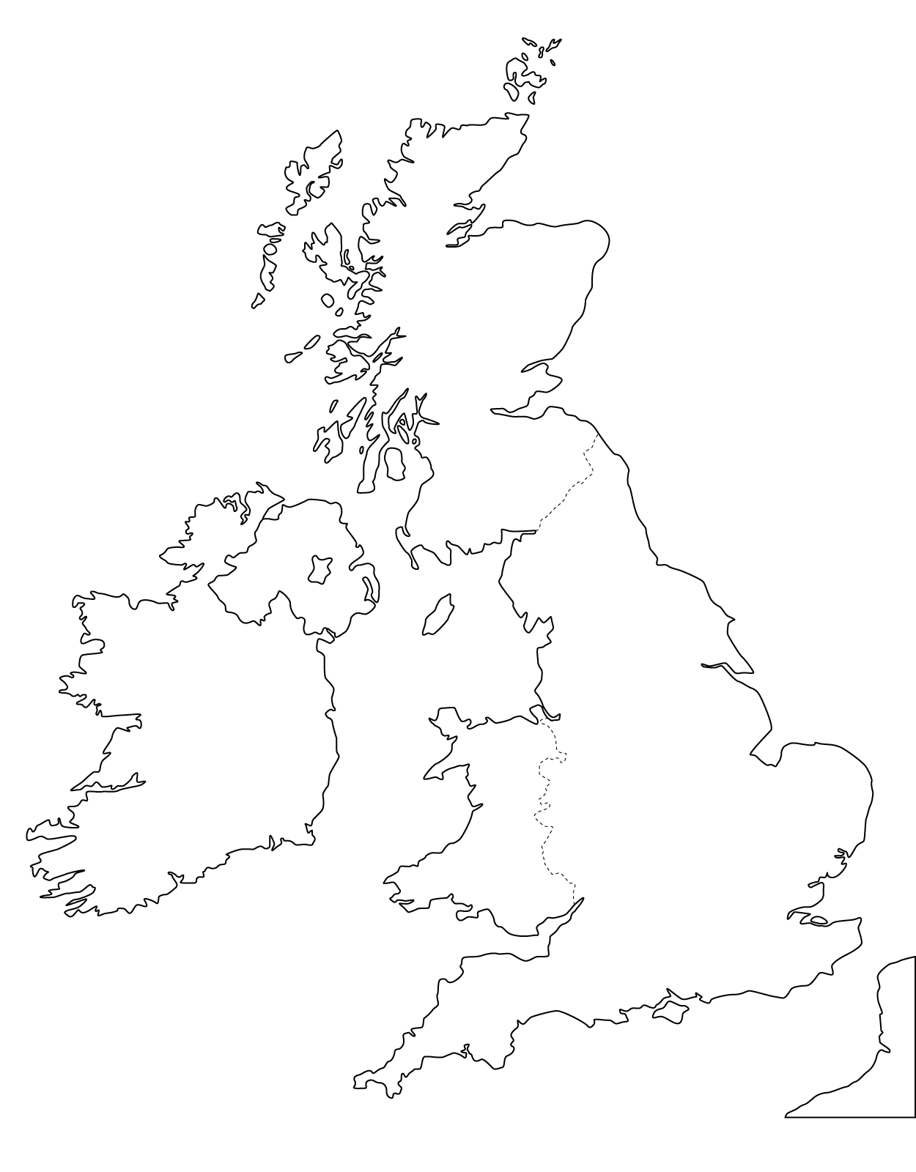-
- Ben Nevis
- Lough Neagh
- Isle of Wight
- Saint George's Channel
- Cardiff
- Hebrides
- Cornwall Peninsula
- North Channel
- Edinburgh
- Liverpool

8
5
1
7
3
4
6
90
10
2
1 | 2 | 3 | 4 | 5 | 6 | 7 | 8 | 9 | 10

…/10
- Write T (true) or F (false)

1 | Ben Nevis is the highest mountain in the British Isles
2 | Ulster is another name for Northern Ireland
3 | London lies on the River Thames
4 | Lake Tekapo is located in the USA
5 | Mount Snowdon is in Wales
6 | Belfast is the capital city of the Republic of Ireland
7 | There are 53 US states
8 | Alaska is a part of Canada
9 | British Columbia is a province in Canada
10 | New Zealand is an island nation in the southwestern Pacific Ocean.

…/10

SYMBOLS
- Complete the sentences
- The flag of the USA is called ……………………….……………………………
- The flag of UK is called ……….............…………………………………………
- There is a Southern Cross constellation on the flags of ……………………………….. and ………………………..
- There is a red maple leaf on the flag of ………………………….. .
- The second widely spoken language in the USA is ……………………………. .
- ……………….. - a group of native peoples inhabiting the Arctic regions of Greenland, Canada and Alaska.
- ……………………. are the indigenous Polynesian people of New Zealand.
- Kangaroo and emu are the symbols of …………………………. .
- Bald eagle is a national bird symbol of ……………………………………… .
- Lacrosse and ice hockey are the most popular sports in ………………………………… .
…/10
- Write the names of the countries next to the titles of the national anthems.
Title | Country
"The Star-Spangled Banner"
"God Defend (…)"
"God Save the Queen"
"Advance (…) Fair"
"Amhrán na bhFiann"
…/5
CULTURE AND LITERATURE
- Put the statements in the correct place.
W. Shakespeare; C.S. Lewis; the Globe Theatre; Capulet; Hagrid; Hogwarts; The Silmarillion; nick name Robert Galbraith; J.R.R. Tolkien; Middle-Earth; actor; Sauron; Ch. Dickens; "father" of modern fantasy literature; The Last Battle; Narnia; Aslan; essayist; A Christmas Carol; Harry Potter and the Deathly Hallows; Jacob Marley; Romeo and Juliet; London; the greatest novelist of the Victorian era; J.K. Rowling,
Lp. | Authors | Titles | Characters | Places | others
1 | W. Shakespeare
2 |  |  |  |  | the greatest novelist of the Victorian era
3 |  |  | Sauron
4 |  |  |  |  | essayist
5 |  | Harry Potter and the Deathly Hallows
…/10
- Complete:

The UK National Days
Country | Saint Patron | Date
Wales
 | Saint Patrick
 |  | 23th April
Scotland
…/8

- Write the dates next to the festivals

E.g. Christmas Eve – 24th December

Festival | Date
Christmas
Halloween
New Year’s Day
Valentine’s Day
Bonfire Night
April Fool’s Day
Boxing Day

…/7

RECOGNIZING OBJECTS AND PLACES
Look at the pictures. Write down the name of the object or place and the country of its origin.
LP. | Country | Name of the object/place
1
2
3
4
5
6
7
8
9
10
…/10

Read the sentences carefully!
Then watch the film twice and decide whether
the sentences are TRUE or FALSE
lp | A DAY OUT IN NEW YORK | TRUE or FALSE
1. | NY is called Big Apple
2. | Manhattan is an island
3. | Central Park is in Manhattan
4. | Outside the Central Park there are the highest skyscrapers in New York
5. | You cannot ride a bike in Central Park
6. | The Time Square is not in Manhattan
7. | Bubba Gump Shrimp is a restaurant
8. | “Phantom of the Opera” and “Wicked” are the most popular Broadway Exhibitions
9. | Broadway is a very quiet area.
10. | The easiest way from Brooklyn to Manhattan is by taking the Brooklyn Bridge

…/10

